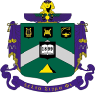
Delta Sigma Phi

SLO / CA
Alumni Newsletter
Issue #16: Spring 2018
Chris “Yabut” Patterson, W’73, Editor, cpatteson76@outlook.com / 530-941-3986

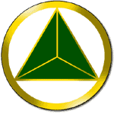
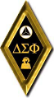
OUR BELOVED CHAPTER
OF 68 YEARS
IS FORCED TO CLOSE

- 2014 Event Begins National Fraternity And ACB 3.5 Year Dialog With University On Behalf Of Our Chapter

- Our Members Have Performed Admirably Since 2014 Event - Under Restrictions - Then Campus Disaffiliation

- After 2 Years Of Campus-Disaffiliation, University Refuses Repeated Requests For Re-Recognition Until Chapter Closes For At Least 18 Months

- National Fraternity Makes A Final Appeal To Cal Poly

- Out-Of-Options, DSP National Reluctantly Agrees To Terms As Only Way To Return Campus-Recognition

- National And Alumni Feel Badly For Innocent Membership Which Was Not Responsible For 2014 Event

- ACB Exhausted - Finances Drawn-Down Over 3.5 Years

- ACB And Alumni Association Need Your Support - There Is Much To Be Done
Editor's Note:

To provide context to those who have not received all or any of our prior messaging since 2014, and to secure for the future facts which may be lost to time, we present more detail in some sections than we normally would due to the importance of this newsletter's subject.

- 2014 Event Begins National Fraternity And ACB 3.5 Year Dialog With University On Behalf Of Our Chapter

September 4, 2014: The community’s newspaper, The Tribune, reported:

“Gear McMillan, 22, of San Luis Obispo was arrested on Thursday, Sept. 4, 2014, on suspicion of possessing marijuana for sales and possession of a controlled substance in the form of nonprescription medication.”

Adding to this embarrassment and violation of fraternal values, the arrested brother was a past President, living at the Chapter during summer break and serving as Housing officer.

The Mustang Daily reported that Derek Morefield, Chapter President, living away during summer break, said, “We’re not going to stand for anything like that”. The Chapter's Executive Board immediately required the arrested brother to move out and requested the National Fraternity to put his pin on suspension pending outcome. Upon conviction and receiving a three-month sentence, the Executive Board unanimously requested National Fraternity expel the brother from Delta Sigma Phi.

The Mustang Daily reported:

"The arrest came while investigating the armed robbery attempt at the Delta Sigma Phi fraternity house on Aug. 10, in which five Cal Poly football players were arrested."

September 9, 2014: Alumni assessed failures in internal chapter governance, communication, and alumni oversight. Four potential failures were identified to remedy:
1. Failure of a brother to follow Chapter rules and meet the duties of his office;
2. Failure of Exec to take strong enough actions to internally correct the conduct;
3. Failure of membership to elevate the issue to alumni; and,
4. Failure of alumni to raise their hands, fill offices, and for alumni officers and alumni-at-large to more frequently travel to the Chapter to assess operations and provide guidance. At the time, and during preceding years, there were vacancies on the ACB, including the critical position of Chapter Advisor.

September 2014 - March 2015:

The Chapter remained University-recognized and was under severe probation restrictions imposed by ACB and National Fraternity. Six months of intensive member training-to-University-and-Fraternity responsibilities, including by-stander responsibilities, took place by National Fraternity and ACB. Many, many new oversight processes were installed at the Chapter. The Chapter responded well. The University seemed satisfied.

This all changed immediately after the weekend of March 7 and 8, 2015. Student events at two leading universities, that had nothing to do with Delta Sigma Phi, went viral for many days in the national news media.

March 7, 2015 (Saturday): University of Oklahoma
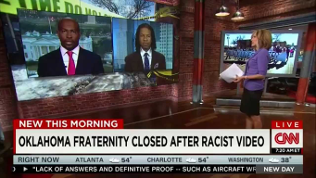
The Washington Post ran the following article-title about the abhorrent racial conduct recorded on a bus at University of Oklahoma, "OU: Frat members learned racist chant at national SAE leadership event".

CNN reported the OU SAE fraternity chapter was closed on March 9.

March 7, 2015 (Saturday): Cal Poly off-campus block party by 1,000 to 2,000 students.

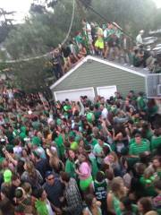
News agencies reported that an unruly, off-campus, early morning block party began at 4:30 a.m., was attended by 1,000 to 2,000 students, and nine were injured. The University reported:

"Many students participated in the activity known as Brewfing (drinking on a roof). This is a recent social phenomenon that Cal Poly students engage in as part of the party culture."

Videos of the gathering went viral on national news media. This resulted in many calls to the University by worried parents, deep University concern over student safety, and embarrassment.

The party was one block from the fraternity house. A DSP mug of a past member was found at the party site. Alumni traced the nickname on the mug to a 2012 initiate who was no longer on roster due to what alumni were told was a mutual member-Chapter parting-of-the-ways over conduct requirements. All Chapter members were out-of-town on a leadership retreat on the morning of the block party.

March 9, 2015 (Monday): University considers actions to take regarding block party

Per the University's subsequently published "Final Report" by Dr. DeCosta on the block party:

"On Monday, March 9, 2015, the Dean of Students department through the Office of Student Rights and Responsibilities (OSRR) made a plan to address the situation."

"All Greek chapters were on 'social probation' during this time (March 7, 2015, block party) and were not permitted to have chapter-related social events."

March 10, 2015 (Tuesday): University puts Delta Sigma Phi on Cease-And-Desist

Dean Kathryn O'Hagan, Coordinator of Fraternity and Sorority Life, initiated investigation of our DSP Chapter for the September 2014 drug-related arrest of a brother. (Editor's note: This University action referenced the 2014 issue, not the March 2015 block party.) The following message was sent to the Chapter and copied to Dean DeCosta and others:

“As a response to allegations regarding an alleged violation of the Cal Poly Fraternity and Sorority Life Alcohol and Drugs Policy, the Epsilon Rho​ chapter​ ​of Delta Sigma Phi ​is Under Investigation." "Effective today, March 10, 2015 the chapter should suspend all functions and may not conduct any events, activities, or participate in Intramural Sports."

May 8, 2015 (Friday): University hearing for Delta Sigma Phi Chapter on charges associated with the September 2014 arrest of a brother on drug charges

Our Chapter President was required to solely represent the Chapter. He was accompanied by attorney Paul M. Phillips, an expert in University proceedings, as an independent observer for the ACB, as no Board members were available to attend.

Mr. Phillips reported to ACB that Dean DeCosta asked the following question, "Is this an organization (DSP) that we can keep at Cal Poly that won't harm students?" Mr. Phillips said our Chapter President replied, "Prior to Gear's arrest, most of the members didn't even suspect or believe any hearsay of him (Gear) participating in these illegal activities."

Our Chapter President reported that during the hearing, the presiding University officer, Dean DeCosta, walked across the room with the DSP beer mug found at the block party, and gave it to him with the comment that she was returning fraternity property. This was our first indication that the University felt DSP was involved in the block party, which we were not.

May 11, 2015 (Monday): University removes campus-recognition for 5 years

Relevant sections of the University's recognition-revocation letter:

"The pending investigation and a judicial hearing were initiated to ascertain the validity to the allegations that the Delta Sigma Phi-Epsilon Rho possessed, distributed, and sold illegal drugs from approximately February 2014 to September 2014. Specifically, chapter members, living in the chapter house, had direct knowledge of the sale and distribution of illegal drugs from the Delta Sigma Phi-Epsilon Rho chapter house."

"Fraternity officers acknowledged that possible violations of University policy did occur during the time in question, but ultimately felt only that "the fraternity is responsible for a lack of action on our part to escalate the issues sooner." "The violations of the alleged policies were facilitated by one member, Gear McMillan."

"Although the chapter officers acknowledged a failure to escalate alleged violations to the appropriate authority, this failure contributed to an unsafe environment of the chapter facility and put Cal Poly students at risk."

"Epsilon Rho officers have stated they are committed to changing the culture of their chapter, but the length of time during which the violations occurred and the sheer number of chapter members involved point to an ingrained attitude of ignorance or blatant indifference for chapter values."

"This series of events reflect a chapter cultural norm that is dangerous and entirely unacceptable. Upon considered reflection; the recognition of the Epsilon Rho chapter of Delta Sigma Phi is withdrawn. The university will simultaneously request of the Delta Sigma Phi Fraternity headquarters that the Epsilon Rho chapter be dissolved. The re-colonization may occur after June 30, 2020 (5 years). Re-colonization is contingent upon full compliance with this resolution by both the local chapter and national headquarters of Delta Sigma Phi."

June 1, 2015: ACB sends Appeal to University

Our Appeal extensively responded to University concerns expressed in the May 8, 2015, hearing. Lacking an advance agenda, our Chapter President was unprepared to address the concerns the University expressed at the hearing.

Paraphrased, these three University concerns were:
a) What is your fraternal process for management?
b) How does your fraternity protect the health and safety of members and the student body?
c) What value does your fraternity provide its members, Cal Poly, and the student body?

The 23-page ACB Appeal provided exceptionally strong answers to these reasonable questions. This report is posted on-line. Reference it by going to http://www.SLOYITBOS.com, our Alumni Association web site. Choose the main menu page REPORTS, at the top of this page find "Newsletter", and open the document "Spring 2015 May 31 Appeal To the University - The Value Of DSP

September 3, 2015: DSP's appeal results in reduction from 5 to 2 years in loss of recognition and required period of chapter dissolution

We cannot be certain which of several potential factors were responsible for this University decision, but we appreciate the thoughtful consideration Vice-President Humphrey extended to us. The two leading candidates are the University's investigative results in the cause of the March 7, 2015, block party, and the Chapter's Appeal.

Probable Influence #1 In Sanction Reduction: DSP was found not responsible by the University for the March 7, 2015, block party. Per the University's "Final Report" on the events of March 7, 2015 (block party), authored by Dean DeCosta:

- "No evidence supports that the Greeks officially promoted or marketed the event."
- "While some members of Greek organizations helped rally groups of Greeks and nonGreeks, from the residence halls, surrounding areas, and so forth, there is no evidence that a specific Greek affiliated chapter or Greek leadership played a role in facilitating the event and the gathering."
- "Many students suggested that social media applications such as Twitter, Yik Yak, Instagram, and Snapchat contributed to the large gathering."
- "Students reported that there was no centralized forum for disseminating information about the event."
- "Most students intentionally became intoxicated prior to the event because there was no expectation of alcohol being provided at the event."
- "It was reported by students that there were a number of simultaneous house parties occurring in the residences near 348 Hathaway, which contributed to the large number of students in the central location."

Probable Influence #2 In Sanction Reduction From 5 To 2 Years: DSP Appeal of June 2015

October 8, 2015: ACB letter to University President Jeff Armstrong

Your alumni asked University President Jeff Armstrong to become involved in our case. We presented five questions, and three benefits of affiliation.

Five Questions:

How will effectively closing a high-performing fraternity chapter benefit Cal Poly students seeking a fraternal affiliation with a values-based, alumni monitored, program of social responsibility and academic excellence?

How will closing a fraternity chapter that does not permit alcohol on Chapter property, and that promotes its property as a safe-haven for its members and guests, promote greater fraternity responsibility within IFC?

How will closing a fraternity chapter after it followed a school-year long period of National and University imposed restrictions and oversight, without a single violation, encourage other fraternities to adhere to such restrictions and oversight?

How will closing a fraternity chapter that provides a practical daily platform for students to apply Cal Poly’s Learn-By-Doing principle, through living and working together, through self-governance and self-policing, benefit the University?

How will closing a fraternity chapter that honors Cal Poly’s academic mission benefit the University and its well-deserved reputation for scholastic excellence?

Three Benefits:

#1. The University will regain authority and influence over various fraternal operations, such as recruitment, party registration and social events, etc.

#2. The University can partner with, and have any concerns addressed by the Chapter’s ACB, alumni, National Fraternity representatives, and National Fraternity Officers to jointly provide comprehensive oversight and risk management of Chapter operations.

#3. The University can achieve its stated Mission. “Cal Poly fosters teaching, scholarship, and service in a Learn by Doing environment…”. The suggested alternative sanction is supportive of continuing student education and growth. It replaces two years of lost opportunity to teach and mentor with the continuing opportunity to develop young men.

Dr. Armstrong's office responded that the President does not become involved in student or organizational disciplinary matters.

This 10-page personal appeal to Dr. Armstrong is posted on-line. Reference it by going to http://www.SLOYITBOS.com, our Alumni Association web site. Choose the main menu page REPORTS, at the top of this page find "Newsletter", and open the document "October 2015 Appeal To University President Armstrong".

October 2015: National Fraternity and University reach accord on chapter operations

Our National Fraternity and Jason Mockford, M.A., Assistant Director, Dean of Students, Student Affairs, Cal Poly, exchanged emails regarding the Chapter. Mr. Mockford indicated the Chapter had the right to operate off-campus and that if extensive University restrictions were met, off-campus operations would not impair return-to-recognition. This subject is further addressed later in this newsletter.

November 2015: National Fraternity MOU with ACB allows Chapter to continue operating

National Fraternity and ACB negotiated a Memorandum-Of-Understanding (MOU) for the Chapter to operate without campus recognition. This unique agreement was the first time in over twenty years that Delta Sigma Phi allowed this. The MOU's content addressed three primary areas:
1. Far great chapter risk management practices and member training;
2. Far greater alumni engagement with National programming and Chapter operations;
3. Far greater reporting between Chapter, ACB, and National.

November 2015 - May 2017: Chapter operates well

Our chapter operated as an off-campus, community-based, student organization, operating under close ACB supervision. Chapter, ACB, Alumni Association, and National Fraternity fully expected to complete our two-year disaffiliated sanction by May 2017 and re-apply for campus recognition. Over the past ten months since May 2017, our National Fraternity and ACB have worked, without success, to gain campus-recognition for the Chapter.

- Our Members Have Performed Admirably Since 2014 Event - Under Restrictions - Then Disaffiliation

Our Chapter distinguished itself over the past three-and-a-half years by reaching new levels of community service, philanthropy, risk-management, recruitment, and academic achievement.

COMMUNITY SERVICE EXAMPLES

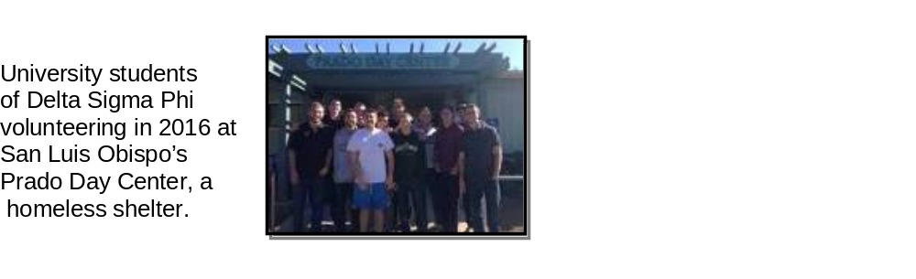
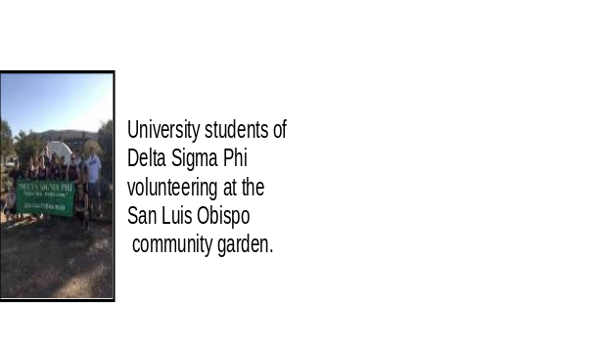

PHILANTHROPY EXAMPLES
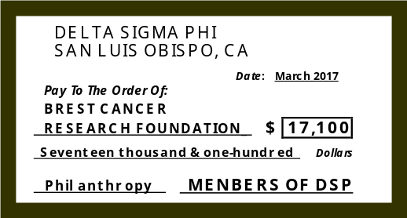
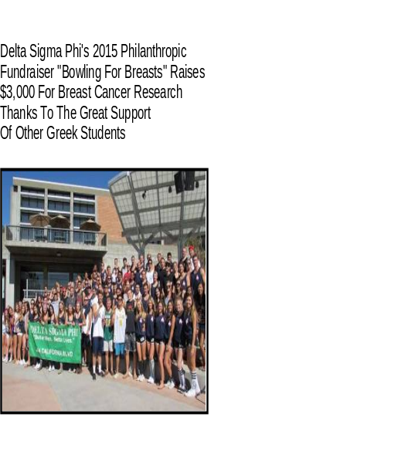

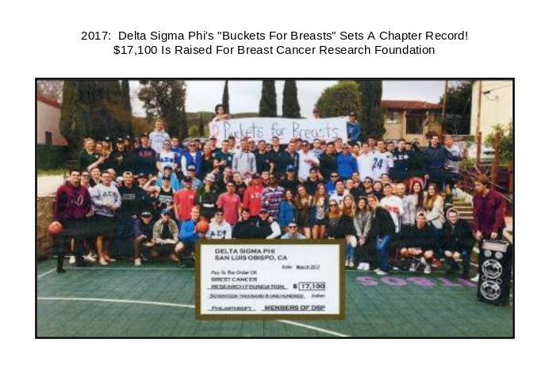

ACADEMIC SUCCESS

In the 2014-2015 academic year, on their own initiative, our members converted a Chapter house bedroom to a study-room. Two GPA charts follow.

The following GPA chart was based upon University-provided records, through the end of Spring Quarter 2015, at which time the University stopped tracking our Chapter's grades.

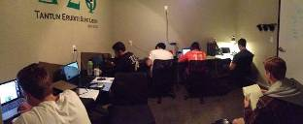
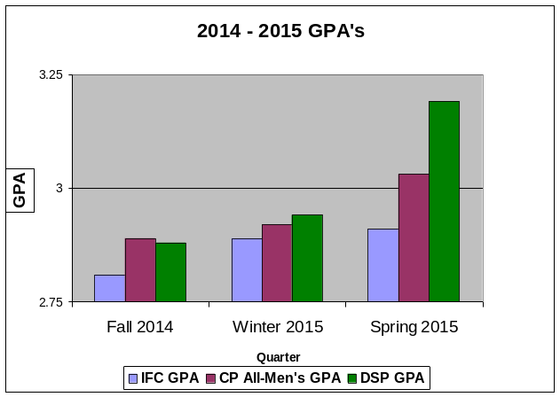

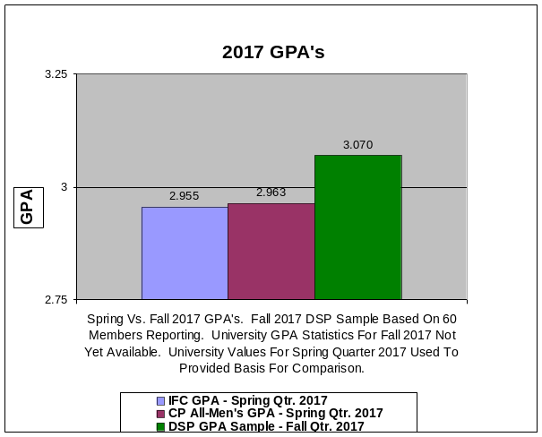

The GPA comparison to the left reflects the University-published GPA's for Spring Quarter 2017 for IFC and All-Men's, and a major statistical sample for DSP GPA for Fall Quarter 2017. The sample is based upon 60 members reporting. University GPA's by group are not yet published on its web site for Fall 2017 as of this newsletter's publication.

- After 2 Years Of Campus-Disaffiliation, University Refuses Repeated Requests For Re-Recognition Until Chapter Closes For At Least 18-Months

May / June 2017: DSP surprised by University position that 2-year sanction had not started

Upon completion of the two-year period of campus disaffiliation in May 2017, our National Fraternity contacted the University for detail on its campus-recognition procedure. Our ACB President participated in this National call to Dean McMahon. DSP was taken-aback by Dean McMahon's surprise that the Chapter was open and operating.

In June 2017 DSP's Executive Director Patrick Jessee called with a briefing for ACB on several conversations and email exchanges that had taken place solely between National and Cal Poly. The following draws from notes of this briefing call.

Patrick said National is solidly with us because of the significant level of alumni engagement with the Chapter and due to our undergrad's and program's success. He thanked all of us.

He also said recent conversations with Dr. Kathleen McMahon, the University's newer Dean of Students, resulted in the following:
1. She felt our members, as individuals, were fine, but that our chapter, as an organization, had not ceased operations for two years and presented a liability to the University;
2. Because of this, a request for recognition at this time would not be approved;
3. Particularly troubling to Patrick and the Grand Council (DSP's national board of directors), the University may modify its student code of conduct to penalize students associated with unaffiliated off-campus student organizations;
4. Our "ED" added that having a Fraternity-University dialog, and knowing their concerns, will help DSP focus conversations and formulate proposals to address their concerns.

National recommended that ACB develop and submit to the University a written, formal, Petition requesting return-to-recognition. ACB was told the Petition, and the University's response, would promote useful dialog.

September 29, 2017: ACB formally petitioned University for recognition

After three-months of intensive development over the summer, and thanks to the input of many including alumni leaders of other chapters with experience in presentations to Universities, ACB submitted a 48-page Petition to the University at the end of September 2017. The following is the four-page executive summary contained in this Petition:

Date: September 18, 2017
To: California Polytechnic State University / SLO
From: Delta Sigma Phi Fraternity Chapter
Regarding: Request For University Recognition

We University students, currently in the Delta Sigma Phi Fraternity Chapter located in San Luis Obispo, respectfully request the privilege and accept the responsibility of University recognition as a student organization. We current members of the Chapter had no involvement in the irresponsible conduct of 2014 that precipitated the Chapter's loss of affiliation. All members associated with such conduct have since graduated in 2014-2017, or chose to no longer associate with our organization and our strict conduct requirements. We promote and apply the University's values and goals, and following the incidents in 2014, we completely overhauled our Chapter's system of internal self-management processes. Our University alumni have significantly expanded their external oversight and guidance systems. In combination, these systems teach student responsibility and accountability, promote risk-management, protect student health and well-being, and enhance student success. We are, in short, a completely new fraternity culture, and believe we have shown, through the corrective measures detailed below, our sincere efforts to contribute to the University's communities.

Eight months prior to the University's May 12, 2015 hearing report, and in complete agreement with these University concerns, the issue-assessment by our Chapter's University alumni identified failures in the systems of the Chapter's internal student-led-management processes as well as failures in the system of alumni oversight and governance. (Exhibit 1)

At the start of Fall Quarter 2014, our University Alumni and National Fraternity aggressively began correcting these behavioral, cultural, and system failures. (Exhibit 2)

Since our May 2015 loss of campus recognition, we have complied with University directives and expectations prohibiting on-campus group activities. We eliminated nine major activities and have respected University trademarks as requested. (Exhibit 3)

Our National Fraternity and University alumni thoughtfully considered multiple options and chose not to close the Chapter after the September 2015 University appeal decision was announced. Closing would have left serious risk elements in-place within the University and student communities. Maintaining an open Chapter, with continued highly-restricted operations and extraordinary levels of alumni and National Fraternity engagement, provided the teaching platform needed to achieve the University's goal of removing risk to students.

This decision supports the University's Campus Health and Well-Being program which recognizes that rehabilitation is essential to restoring a student's, or organization's, standing and ability to again succeed in their mission and contribute to the larger community. (Exhibit 4)

In support of President Armstrong's University mission elements of "civic engagement", "encouraging co-curricular experiences", and "Cal Poly promotes the application of theory to practice" (Exhibit 4-a), we were converted to an off-campus, community-based, student organization. Specifically we:
- Emphasized our social responsibility to those less fortunate through a program focused on service; (Exhibit 5)
- Emphasized our responsibility to community by a program emphasizing philanthropy; (Exhibit 6)

In response to University concerns, we have developed completely new and comprehensive internal Chapter management systems and processes. We have:

- Revised Chapter house rules, expectations, and consequences of failure to meet standards; (Exhibit 7)
- Created a judicial review board with authority over all student members; (Exhibit 8)

To further assure effective, responsible, and ethical Chapter management and student development in compliance with University guidelines, major changes have been made in the system of alumni oversight and governance. Our alumni:

- Created an Issue Escalation Program as a preventive measure; (Exhibit 9)
- Staffed vacant and underperforming Alumni Corporation Board (ACB) positions; (Exhibit 10)
- Added an additional alumni oversight body; (Exhibit 11)
- Sent ACB officers and Advisors to multi-day Chapter management training; (Exhibit 12)
- Meet with members at the start of Fall Quarter to stress that we make good decisions, coordinate goals and objectives, and perform our individual member reviews; (Exhibit 13)
- Require frequent Chapter reporting and removed communication bottlenecks; (Exhibit 14)
- Revised Chapter house resident leases to mirror University housing leases; (Exhibit 15)

In support of the University's Article 5 Student Conduct Standards, and the University's commitment to "maintaining a safe and healthy living and learning environment for students", we:

- Revised our rules for social functions at or away from our Chapter house and property, establishing a zero-tolerance risk management policy emphasizing by-stander responsibility, with member education regarding alcohol, drugs, and sexual harassment; (Exhibit 16)
- Installed a sports-court at the Chapter as an alternative to alcohol consumption; (Exhibit 17)
- Created mandatory quiet-hours and a dedicated study room to promote academic achievement; (Exhibit 18)
- Created the student Executive Board position of House Scholar to reinforce the goal of academic success; (Exhibit 19)
- Installed high-speed internet access at the Chapter's property; (Exhibit 20)
- To support our education, our University Alumni Association and ACB:
(a) Increased the number of scholarships and aligned them with our five core values to further incent character-development and academic achievement, (Exhibit 21)
(b) Provided an additional $35,000 to $40,000 a year in reduced rents, officer compensation, meal cost reductions, and work-study programs; (Exhibit 22)

In furtherance of the University's "Statement of Commitment to Community" and its objective of "Accept responsibility for our individual actions", we designed and required every member to sign a Standards Agreement governing each member's personal responsibility for his conduct. (Exhibit 23)

In support of the principles underscoring the Dean Of Students "Community Service and Philanthropy Council" mission, "to bring together Cal Poly clubs and organizations with a community service and philanthropic focus", we have over the past two years:
- Raised over $25,000 for charity;
- Performed over 1,500 hours of service;
- Won a National award for philanthropy; (Exhibit 24)

Consistent with University policy, "The Cal Poly Dean of Students Office promotes student development and leadership", we have received significant, continuing, leadership training:
- All student-members attend a Regional Leadership Academy (RLA); (Exhibit 25)
- A selection of student-officers on our Chapter's Executive Board attend Fraternity trainings in Indianapolis, Indiana; (Exhibit 26)
- Our University alumni encourage us to serve in campus government and in club leadership positions; (Exhibit 27)

Building on the University's Orfalea College of Business "Young Alumni Mentoring Program", Chapter alumni introduced the "Senior Transition" program last year which enables us to gain industry insights and learn career-development skill-sets by being matched with a high-performing alumnus/mentor in our field. (Exhibit 28)

Just as the University's Health and Well-Being Center provides students with skill-sets to "make better decisions" because, "Many students find that choices related to alcohol and other drug use are a challenging part of their college experience", our alumni provided and trained us in using a new group-and-personal decision-making model:
- Values-based decision-making - which guides personal and group decisions by comparing potential actions to conduct targets; (Exhibit 29)
- Key Performance Indicators - metrics to measure conduct in relation to attainment or shortfall in living-to values standards ; (Exhibit 30)

In direct support of the Dean of Student's "Student Community Service" program's mission element of "encouraging students to be positive community members of the San Luis Obispo Community", the city's police department has confirmed that "The fraternity has been a good neighbor and remains in good standing with the city". (Exhibit 31)

During the past three years the University sent us several letters of concern, warning, or accusation. Subsequent University investigation found us innocent of all but one minor misunderstanding; a member's rush card in September 2015 which was not authorized by the Chapter's Executive Board and which was immediately rescinded. (Exhibit 32)

Our University alumni lead-by-example: They encourage our social-awareness-development and responsibility to community by including us in far greater numbers in their philanthropic works:
- Our charity golf tournament has provided Aware, Awake, Alive $50,000 in the last five years to benefit the health and safety of all students. (Exhibit 33) Our charity tournament now fundraises for this program under University sponsorship. (Exhibit 34)
- Our Poly P Scholarship for non-Greek students has provided $10,000 over five years and was expanded in 2016 to include women applicants, judged by women, to reinforce gender-equity and respect for women; (Exhibit 35)

In furtherance of University student-development goals, our 2017-2018 plan includes the following new or expanded program goals suggested by our alumni which our Executive Board will shortly begin discussing with student-members:

- Installation of the "Visiting Alumni Speakers" program; (Exhibit 36)
- Expansion of the number of volunteerism opportunities; (Exhibit 37)
- Establishing the goal to increase to 100% our student involvement in an additional campus-recognized club or student activity; (Exhibit 38)
- Having all student-members take training during Fall Quarter 2017 in GreekLifeEdu - a national on-line prevention program designed for college students who are members of Greek-letter organizations. The program addresses alcohol, drugs, sexual conduct, and hazing. (Exhibit 39)

We undergraduates and alumni request that our organization again be able to serve our University, as we have in the past. (Exhibit 40)

The inappropriate student culture present at the Chapter in 2014 has been replaced with one which stresses individual accountability and by-stander responsibility to others. We respectfully seek the University's encouragement and recognition for what we have accomplished. We have learned, discussed, applied, and promoted the University's goals for socially responsible student conduct, community involvement, academic achievement, and meet or exceed the standards of current on-campus student organizations. For these reasons, we respectfully ask for official University recognition of Delta Sigma Phi as a Cal Poly student organization.

(end of September 29, 2017, executive summary of Petition)

To view the entire 48-page Petition, go to http://www.SLOYITBOS.com, select "REPORTS" from the menu, and at the top of this page, under "Newsletters", choose "Petition For University Re-Recognition September 2017".

January 19, 2018: DSP National officers, and Chapter Advisor, meet in SLO with University

National Fraternity President Jim "Lurch" Larson (Epsilon Rho W'72), DSP National Grand Council board member Ken Riley, and DSP National Fraternity Executive Director Patrick Jessee flew to SLO to meet with the University. Our excellent Chapter Advisor Bill "FUBAR" Bradley, F'63, accompanied the team and represented ACB. ACB and Alumni Association well-briefed the negotiating team prior to the meeting.

Our negotiating team reported that Dean McMahon did not believe the University previously made the statement that the chapter had the right to operate off-campus, and did not state that such operation would have no impact on future recognition. The position of the two Deans at the meeting was that no amount of demonstrated risk-management, community service, philanthropy, or chapter respect for the University's disallowed on-campus operations and banned IFC involvement would remedy the lack of chapter dissolution for two years.

- National Fraternity Makes A Final Appeal To University

March 14, 2018: DSP National sends formal written response to University regarding the January 19, 2018, meeting - with rationale for rapid return to recognition

March 14, 2018: Cover Email - National To Cal Poly
"Dear Dr. Humphrey:
Attached you will find our formal appeal to Cal Poly’s decision regarding the loss of recognition of Delta Sigma Phi. I hope you can find the time to earnestly review our case and that you personally will consider the merits of our request for a guaranteed rapid reinstatement.
I’m sure you’ll agree that punishing those current members of the fraternity, who had nothing to do with an incident that happened over 3 years ago, and who have displayed exemplary behavior during that time, seems heavy handed and unmerited punishment. Being ostracized from the Cal Poly family and the IFC, being unable to engage as a member of the campus community, and being unable to bring new members into the fraternity in the normal IFC and University controlled manner has been a significant burden. Yet the chapter has survived and excelled in every way possible.
Please bring these innocent young men back under the oversight of the University as soon as possible. They are only asking to become part of the full student body of the University they are so proud of. As you will see in our attached appeal (including information which you may have previously not seen), and which we hope you will agree with, they have truly earned it.
Sincerely,
James W. Larson, National President, Delta Sigma Phi
Cal Poly, BS 1975, MBA 1976"

March 14, 2018 - Excerpts Of National's Appeal To Cal Poly

The letter provided a summarized rationale for the Fraternity's request for rapid return to University recognition of the chapter.

"As documented in the attached email chain, Delta Sigma Phi operated in good faith under the understanding (articulated by the University) that recruiting and operating off-campus would not jeopardize recognition."

"Despite assertions by the University that we would be made aware of any concerns related to our potential recognition, we were never provided any indication that recognition was in jeopardy until Dr. McMahon's letter in May of 2017. Since that time, we have attempted to engage the University in dialogue related to this sanction."

"Delta Sigma Phi has operated according to the University's directives as clarified to us, and has had no health and safety violations for 3.5 years (and has instituted significant measures to prevent against such)."

"While the initial rationale for loss of recognition was a concern for student health and safety, the rationale for an extended period now appears to be related to the University's concern of liability, and as stated by Dr. McMahon, an aversion by some in the IFC to positively consider our return."

"Given the demonstrated history of the chapter over the last 3.5 years, that liability concern seems unfounded, remote at best, and logically in contribution with the University's continuing recognition of other chapters who have recent health and safety conduct violations."

"While significantly disconcerting to the existing membership, we will cease operations immediately through August in deference to the now understood position of the University, however, we do not understand where there is any compelling rationale for an additional punitive extrajudicial extension of the loss of recognition imposed on a group of men who have exhibited high character, contribution, and merit and none of whom were engaged in either the original event that caused the suspension, or any health and safety violations from that time forward."

"The University explicitly reinforced that we (chapter and governing alumni) were engaging appropriately through conversations with chapter leadership when any issues arose by commending our engagement and proactively noting there was interest in returning to a partnership of recognition."

"In Conclusion:
Isn't the chapter's recognition preferable to dissolution when that chapter's parent organization and governing alumni strongly reinforce the University's goals for student health, safety, well-being, academic achievement, socially-responsible conduct, leadership development, respect for others and their views, and community service?"

"And when they have acted in the highest standards of conduct and behavioral expectations, isn't it an ideal opportunity to allow them to re-enter the Cal Poly community as an example of a highly effective representative of the University's Greek system?"

"When considering the restrictions we have already complied with (consistent with the University's clarification), isn't the concept of community service and education-to-responsibilities, instead of dissolution, a preferable teaching method for a responsible organization, and more in-line with the University's "Learn By Doing" philosophy?"

"Because we want to be collaborative, and establish and model a partnership with the University, our appeal at this time is to remove the eighteen-month cessation mandate from our men, allow a deferential period of cessation until the Fall of 2018, and develop a group mind set for moving forward. Our men have already, as per your request at our meeting of January 19, 2018, ceased recruiting. We continue to monitor, discuss and work with the undergrads, alumni and national headquarters, for an acceptable resolve, and respect the current status of cessation."

"Please honor our appeal and put us all back at the table to move forward for the betterment of all.

Respectfully, and inter-fraternally yours,
James W. Larson, National President, Delta Sigma Phi"

- Out-Of-Options, DSP National Reluctantly Agrees To Terms As Only Way To Return Campus-Recognition

On March 19, 2018, the University again refused recognition but offered an 18-month versus 24-month chapter closure period. An additional matter influenced National's acceptance of Cal Poly terms.

In November of 2017, the University took action against another disaffiliated national fraternity chapter at Cal Poly: PKE. Per DSP Executive Director Patrick Jessee and approved for newsletter publication:

"As background, Dean McMahon had counseled me over the summer (during a conversation I had with her advocating for our return to recognition) that the University was likely to hold individuals accountable for violations of the student code of conduct for engaging with unrecognized groups."

"In mid-November (2017), I learned that Pike would be dissolving, and reached out to their Executive Director to discuss the background. Several parents of the members had been engaged in the process and had been supportive of and advocating for the men to continue their operations. However, when the University suggested that individual members were going to be held accountable for conduct violations occurring at chapter property, the parents encouraged the men to give in."

National's closure message was received April 1, 2018.

"April 1, 2018

To our Brothers of the Epsilon Rho Chapter of Delta Sigma Phi Fraternity at Cal Poly State University – San Luis Obispo:

On March 19, 2018, Delta Sigma Phi received final notice from University administration that our appeals to regain recognition of the chapter will not be granted. The University will not recognize the chapter as an affiliated entity until all operations have ceased in their entirety for a period of 18 months.

This decision is the result of extensive conversations and negotiations driven by the alumni and the national Fraternity with the university. Since this fall, we have exerted every resource, opportunity, relationship, and argument at our disposal. We have championed the character of our undergraduate men, the dedication you all have made to exemplify our ideals through service and philanthropy, and the dedication to improving and executing sound risk management and operations during a difficult and ambiguous time. We have been proud to take this opportunity to share the truth of your commitment over the past several years with the university, because you all have done such an exemplary job in carrying this chapter forward with respect. The efforts from this fall are an extension of the ongoing commitment of the alumni and national office to support the chapter throughout this process – from extensive support during the 2014‐15 academic year to improve chapter operations following the initial incident, to coordinating an appeal that reduced an initial 5 year closure to two years, and the creation and execution of a unique framework for the chapter to continue operating without recognition.

Unfortunately, at this point, a temporary closure of the chapter and cessation of all operations is the only option remaining to regain University recognition and a full and respected inclusion in the Greek community at Cal Poly. It is with a heavy heart that our Grand Council will be revoking the charter for the Epsilon Rho Chapter.

As a result of the revocation of the chapter’s charter, the following expectations are to be adhered to:

1) All operations of the chapter must cease in their entirety. This includes, but is not limited to, social engagements, recruiting, philanthropy, and other general operations as a chapter.
2) As undergraduates at the University, you are not to represent yourselves as a chapter of Delta Sigma Phi or take any actions as individuals or as a group that would imply you are doing so.
3) You are ineligible to be an active undergraduate member of Delta Sigma Phi. Therefore, this letter serves as a formal notification that you are considered an alumnus member of the Fraternity, pending continued acceptable conduct, financial, and academic standing. As a member of the Fraternity, you are still required to uphold the expectations of membership, and any violation of our code of conduct or of the requirements to cease operations can result in your suspension or expulsion from the Fraternity.

Delta Sigma Phi Fraternity is committed to upholding our standards and fostering meaningful Fraternity experiences for our members. The news of the chapter's closure is—without a doubt—upsetting for all Epsilon Rho undergraduate members, Fraternity alumni and other supporters, as it is for our National Fraternity. While difficult in the short‐term, the National Fraternity is committed to working diligently with our alumni and the Cal Poly University community to restore Epsilon Rho Chapter with Men of Courage, Action and Excellence in the future. If you have further questions, please contact Patrick Jessee, Executive Director & CEO, at the Delta Sigma Phi National Fraternity Headquarters.

YITBOS

Patrick F. Jessee, JD, CAE Executive Director & CEO"

- ACB Exhausted - Finances Drawn-Down Over 3.5 Years

You follow the news. You are only too aware that today's environment for fraternity operation is complex and demanding. Your alumni leadership team volunteers their time and energy because, like all alumni, we greatly value our continuing fraternal experience and want others to have the best lab-on-life that we had - DSP - and for our unique legacy to continue forward.

In the last three-and-a-half years, ACB and Alumni Association officers and other involved alumni have collectively invested thousands of man-hours and many tens of thousands of organizational dollars. This investment has been in addition to the usual baseline level of activity and expenditures experienced in normal operations.

The following are examples of unusual time demands. The six-month period after the arrest, and prior to Cease-And-Desist, required an additional 300 to 400 ACB staff-hours. The intense two-month Cease-And-Desist period required at least 200 officer-hours. ACB's June 2015 23-page Appeal to Cal Poly on the value of DSP required at least 200 officer-hours, and very probably more. Our 10-page October 2015 appeal to President Armstrong required about 100 hours. ACB's November 2015 MOU development with National Fraternity required officers to invest at least 250 combined hours. ACB's 48-page September 2017 "Petition For Recognition" to Cal Poly for return-of-recognition took all summer. Let's conservatively estimate this report at 400 officer-hours.

ACB invested many tens of thousands of dollars in MOU-Agreement-required member trainings and expanded alumni engagement in Chapter operations. ACB also invested in leadership retreats, recruitment assistance, GPA incentives, and scholarships. One example may be helpful to you in understanding the financial demands on ACB since September 2014. In November 2014, the cost for a required member-training off-property was $6,000. ACB felt it necessary to spend $20,000 in legal costs to defend the Chapter and members, defray part of National's legal costs on our behalf, and provide ACB with legal guidance.

Please be assured that your ACB and Alumni Association officers exhausted themselves and prudently used funds to improve, defend, and preserve our beloved Chapter. We also set a record for conference calls, chapter visits, and sent more messages than Western Union.

- National And Alumni Feel Badly For Innocent Membership Which Was Not Responsible For 2014 Event
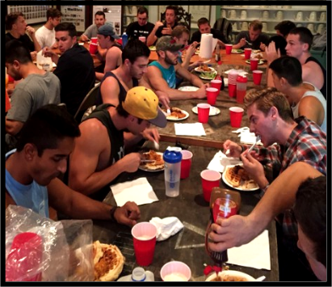
The Chapter's current 73 members were in high school when the events of 2014 occurred, and are innocent.

They did everything asked of them by ACB and National Fraternity. They learned and applied excellent risk-management protocols. They created values-driven Chapter rules and a judicial-review board. Their peer-review held members accountable for actions as well as providing training-to-responsibilities. The photo at left is of their 2017 Thanksgiving dinner.
They won National Fraternity awards - best in the Fraternity for recruitment in 2014-2015 and National runner-up for philanthropy 2016-2017.

They respected the University's list of prohibitions during campus disaffiliation; we all expected this would lead to recognition. These included no IFC sports, no IFC Greek Week, no IFC Rush Week, no exchanges with sororities, no use of campus facilities, no group activity on campus including a group-wearing of fraternal letters, no use of University trade-marked names in association with the fraternity (no Cal Poly and DSP or Epsilon Rho used together).

On April 2, 2018, three alumni officers traveled to SLO and addressed membership. Our men were told that all options on their behalf for campus-reinstatement had been exhausted. We told them that our National Fraternity had to reluctantly remove the charter as the only means left to return the Chapter to campus recognition, IFC involvement, and a full fraternal experience. Your editor was one of the three officers. Our members were saddened beyond my ability to convey, but they took it like men. We explained the fraternal program was ended, not their bond, brotherhood, character, or Delta Sig values.
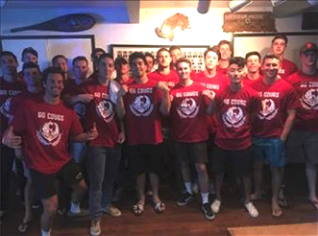
Exec officer Griffin "Web" Laymon recently sent us the photo to the right with the following note: "Members of DSP raised $1,000 for youth-at-risk and the LEMO Foundation. This NFP organization educates and inspires at-risk youth to unleash their potential in academics, athletics, and life-skills."

These men are high-bond brothers of solid character, who have exhibited great maturity over an extended period of difficult operations. You should be very proud of them.

- ACB And Alumni Association Need Your Support - There Is Much To Be Done

So, guys, here we are. We brothers of seven decades have a shared SLO-Delta-Sig experience - and a shared hope for our Chapter's future. Whether you agree or disagree with the decisions made, we must look forward. Whether you are an older or a younger alumnus, you feel the same brotherly-bond and appreciate what DSP did for you.

These are unusual times. We must ask you for an unusual amount of support.

We need your financial help now and for the next two years - and soon we will need your help in other ways.

AA needs $30,000, and frankly, more would enable us to also support ACB work on the House. Not a cent of it is tax-deductible. Here is where it will go!

- ACB And Alumni Association Need Your Support (continued)

These are unusual times. We must ask you for an unusual amount of support.
,
We need $6,000 for PALM - Preserve All Legacy Memorabilia

ACB has just asked us (AA) to take-on the responsibility of packing and storing all our unique and irreplaceable paddles, plaques, Presidents' pictures, trophies, framed history displays, mugs, etc., in secure off-site storage. This will prove to Cal Poly that the 18-month period has begun, allow for renovation work, and protect our memorabilia from outside vandalism or theft.

We need $5,000 for the scholarships we promised the men

These are for the period April 1, 2017 to 2018. We have already judged the applications.

We need $5,000 for our Association's base-line operations to serve alumni

This is for communications, printing, postage, newsletters, web site, directory. More than ever we need to be a unified body of men - to promote our Chapter's return!

We need $4,000 to greatly expand our search for missing alumni

We need to find over 500 MIA alums - and ask them to join in our Chapter-return efforts.

We ask for your help in meeting an AA goal - supporting ACB

AA's initial goal is to provide ACB with $10,000 to meet the upcoming-year's property taxes ($6,000) and insurance ($4,000) on the House - while they figure-out next year. Concurrent with ACB's routine Chapter operating costs, and the additional large expenditures to defend and promote the Chapter, ACB was forced to spend an additional $50,000 from reserves. This included replacing rotted fencing, installing a city-required retaining wall, and reinstating our tax-exempt status, lost in a prior decade, to avoid significant taxes and penalties.

How To Give By Check:

Please make your check payable to DSP EP Alumni Assn. and mail it to Ray Calande (“Mumbles”, W’74) at 1384 Rue Avati, San Jose, CA 95131-2547

How To Give Electronically:

Go to PayPay.com, follow instructions, and give to: dsp_at_calpoly@att.net.

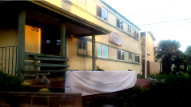
This photo of our covered letters was taken Wednesday, April 4, 2018. It is heart-breaking beyond the ability of words to adequately express. The Nile has stopped flowing. A deep emotional connection to our developmental college years has been interrupted. Please help us return our DSP legacy through your giving, your volunteerism when asked, and keeping your directory info updated (http://www.SLOYITBOS.com, "Update Contact Information").

On behalf of your alumni officers and volunteers, YITBOS, Yabut, W'73,
SLO DSP Alumni Association Officer

